Cape Economic Performance and Prospect Bulletin – July 2026
Highlights
- Price pressures expected to sustain moderation in 2026 although this is highly threatened by ongoing crisis in the middle east.
- Nigeria’s output growth in 2026 is expected to remain positive as economy the stabilises and consolidates reforms.

Global Economic Update
Global economic activity remained resilient through the first half of 2026. While growth momentum strengthened at the beginning of the year, the global economy subsequently faced renewed pressures arising from the Middle East conflict, elevated commodity prices, persistent geopolitical tensions, and tighter financial conditions. These developments increased uncertainty, weakened trade prospects, and heightened downside risks to the global outlook. Nevertheless, the mid-June agreement between the United States and Iran, which paved the way for a ceasefire and the reopening of critical energy transit routes, significantly reduced immediate risks to global energy supply and improved market sentiment toward the end of June.
Among advanced economies, the United States continued to provide the principal support to global growth. Economic activity remained underpinned by relatively robust household spending, a resilient labour market, and sustained investment in artificial intelligence, advanced manufacturing, and digital infrastructure. These factors have continued to support productivity growth and investment despite the persistence of restrictive monetary conditions. In contrast, economic performance in the euro area remained comparatively subdued, reflecting weak industrial activity, lingering competitiveness challenges, and the adverse effects of elevated energy costs earlier in the quarter. Although fiscal support measures and easing supply constraints provided some relief, the pace of recovery remained modest.
Growth in emerging market and developing economies (EMDEs) continued to outpace that of advanced economies, supported by relatively strong domestic demand and ongoing public and private investment. India and several Southeast Asian economies maintained robust growth trajectories, benefiting from infrastructure spending, expanding services sectors, and resilient consumer demand. However, these economies became increasingly exposed to risks associated with geopolitical fragmentation, disruptions to trade routes, and higher shipping and logistics costs during the quarter. In China, economic conditions showed gradual improvement as the effects of earlier policy support measures continued to filter through the economy. While structural weaknesses in the property sector persisted, improvements in investment activity and business confidence contributed to a cautious recovery. Nonetheless, uncertainties surrounding external demand and the global trade environment continued to weigh on the outlook.
The global disinflation process lost momentum during the second quarter. After moderating through much of 2025 and early 2026, inflationary pressures re-emerged as energy prices increased sharply following disruptions to Middle Eastern energy supplies. Supply-chain bottlenecks and higher transportation costs also contributed to renewed price pressures across several economies. In major advanced economies—including the United States, the United Kingdom, and the euro area—headline inflation recorded intermittent increases during the quarter, largely reflecting higher energy and commodity prices. Although inflation rates generally remained well below the peaks observed in previous years, the improvement seen earlier in the year became less pronounced.
Despite these developments, underlying inflation trends in most advanced economies remained broadly consistent with medium-term disinflation objectives. Medium-term inflation expectations have generally remained anchored, reflecting continued confidence in central banks’ commitment to price stability. However, the balance of risks has become less favourable, with inflation increasingly sensitive to geopolitical events, commodity price movements, and labour market tightness. Consequently, major central banks have maintained a cautious and data-dependent policy stance, with expectations of a slower pace of monetary easing than previously anticipated.
Inflation dynamics across EMDEs remained uneven. Several Sub-Saharan African economies experienced further moderation in inflation during the first half of the year, supported by improved agricultural production, earlier monetary policy tightening, and relative exchange-rate stability. However, these gains became increasingly vulnerable following the sharp rise in global energy prices during the second quarter. In a number of commodity-importing economies, higher fuel and transportation costs have begun to reverse earlier disinflation trends, while inflation in several countries remains in double digits. The impact has been particularly pronounced in economies with limited fiscal space and high dependence on imported energy products.
Figure 1: Year-on-Year Inflation in Selected Economies (April 2026 – May 2026) in percent

Source: Various National Statistics Offices
Monetary policy across major economies became increasingly divergent during the second quarter of 2026 as central banks responded differently to the inflationary consequences of the Middle East conflict, elevated energy prices, and varying domestic growth conditions. While concerns regarding inflation persistence and energy-related shocks have strengthened the case for caution globally, policy responses have become less synchronized than previously anticipated.
In the United States, the Federal Reserve maintained its target policy rate at 3.50–3.75 percent at its June meeting, citing solid economic growth, strong investment activity, and inflation that remains above the 2 percent objective. While labour market conditions remain relatively stable, policymakers emphasized that elevated uncertainty, particularly arising from the Middle East conflict and resulting energy price increases, warrants a cautious approach. Consequently, the Federal Reserve has signalled that any future policy adjustments will remain highly dependent on incoming data and the evolution of inflation risks.
By contrast, the European Central Bank (ECB) adopted a more restrictive stance in June, raising its key policy rates by 25 basis points. The ECB cited renewed inflationary pressures stemming from higher energy prices and the risk of broader second-round effects on prices and wages. Although euro-area growth remains weak and is projected to slow further in 2026, policymakers judged that maintaining price stability required a firm policy response. The ECB also reiterated its commitment to a meeting-by-meeting, data-dependent approach amid exceptionally high uncertainty. Elsewhere among advanced economies, policy decisions have reflected differing domestic conditions. The Bank of Japan continued its gradual normalization process, raising interest rates further as inflation became more firmly established around target levels. In contrast, the Bank of England maintained a cautious stance amid signs of slowing economic activity and lingering inflation pressures. These differing policy trajectories underscore the growing fragmentation of the global monetary policy landscape.
In emerging market and developing economies (EMDEs), central banks continue to face a more complex set of policy trade-offs. The combination of elevated global uncertainty, volatile capital flows, exchange-rate pressures, and higher imported inflation has limited the scope for monetary easing in many jurisdictions. Policymakers remain focused on preserving macroeconomic stability, anchoring inflation expectations, and safeguarding external balances, particularly in economies with constrained fiscal space and limited foreign exchange buffers.
The resurgence of energy-related inflation has reinforced concerns that progress toward price stability may be slower than previously expected. As a result, central banks are increasingly emphasizing flexibility, caution, and data dependence in their decision-making frameworks. Expectations of a rapid and synchronized global easing cycle have therefore given way to a more gradual and conditional policy normalization path, with interest rates likely to remain restrictive in many economies for an extended period.
Overall, the global monetary policy environment at end-June 2026 is characterized by heightened uncertainty, divergent policy trajectories, and persistent inflation risks. While the recent easing of geopolitical tensions has reduced immediate threats to energy markets, central banks remain vigilant to the possibility of renewed shocks and continue to prioritize price stability alongside financial and macroeconomic resilience.
Global equity markets experienced a more volatile performance in June 2026 following the exceptional gains recorded during April and May. Although major indices reached new record highs early in the month, investor sentiment became increasingly cautious amid concerns over elevated valuations in artificial intelligence (AI)-related stocks, persistent inflationary pressures, and evolving monetary policy expectations. Nevertheless, market performance remained broadly positive on a quarterly basis, supported by strong corporate earnings, continued AI-related investment, and improving geopolitical prospects following the US-Iran ceasefire agreement.
In the United States, the S&P 500 briefly surpassed the 7,600 mark at the beginning of June before retreating during a mid-month technology-led correction. By month-end, the index closed at approximately 7,499, representing a modest decline of about 1 percent for June but still recording its strongest quarterly performance since 2020. The Nasdaq Composite experienced a sharper pullback as investors reassessed AI-related valuations, ending the month at 26,214. In contrast, the Dow Jones Industrial Average continued to benefit from sector rotation into industrials, healthcare, and financial stocks, reaching a new record close above 52,300 by the end of June. Market breadth improved despite weakness in several mega-cap technology stocks, suggesting a broadening of investor participation beyond the AI sector.
Market dynamics during the month reflected a transition from the highly concentrated AI-driven rally that characterized earlier periods. Concerns about the sustainability of large-scale AI infrastructure spending, reports of delays to major technology listings, and rising financing costs prompted a correction in semiconductor and technology stocks. However, capital largely rotated into defensive and cyclical sectors rather than exiting equity markets altogether. As a result, healthcare, biotechnology, industrials, and financials emerged as notable beneficiaries of changing investor preferences.
Financial markets also remained sensitive to monetary policy developments. The Federal Reserve maintained its policy rate at 3.50–3.75 percent in June, but stronger-than-expected inflation data and a more hawkish policy outlook led investors to scale back expectations of near-term rate cuts. Treasury yields remained elevated, reflecting concerns that inflation could prove more persistent than previously anticipated. Consequently, market participants increasingly shifted from pricing in policy easing toward the possibility that interest rates could remain restrictive for longer.
Geopolitical developments continued to shape global market sentiment throughout June. The most significant development was the signing of the US-Iran ceasefire arrangement and the reopening of the Strait of Hormuz to commercial shipping. This reduced immediate concerns regarding energy supply disruptions and contributed to an improvement in global risk sentiment toward the end of the month. However, broader geopolitical risks—including continuing tensions in Eastern Europe and ongoing global trade fragmentation—continued to generate uncertainty for investors and businesses alike.
Commodity markets reacted strongly to the easing of tensions in the Middle East. Crude oil prices declined substantially during the second half of June as concerns over disruptions to Gulf energy supplies diminished. Brent crude, which had traded at elevated levels earlier in the conflict, retreated to around US$73 per barrel by month-end, while WTI crude fell to near US$71 per barrel. The sharp decline in energy prices helped alleviate some inflation concerns globally and provided relief to energy-importing economies. However, weaker oil prices also raised concerns regarding revenue prospects among major hydrocarbon-exporting countries.
In precious metals markets, gold prices exhibited mixed performance during June. While lower oil prices and easing geopolitical concerns reduced safe-haven demand, lingering inflation risks and policy uncertainty provided underlying support. Gold remained elevated by historical standards, supported by continued central bank purchases and investor demand for portfolio diversification amid heightened macroeconomic uncertainty.
Cryptocurrency markets experienced heightened volatility during June as shifting expectations regarding interest rates and fluctuations in broader risk sentiment influenced investor behaviour. Bitcoin and other major digital assets benefited initially from strong institutional interest and improving risk appetite. However, volatility increased later in the month as investors responded to changing monetary policy expectations, technology sector weakness, and broader market uncertainty. Despite periodic selloffs, institutional participation in digital assets remained significant, supported by continued regulatory developments and sustained venture capital investment across the digital asset ecosystem.
Overall, developments during June 2026 highlighted the increasingly interconnected nature of global financial markets, monetary policy, geopolitics, and commodity prices. While the easing of Middle East tensions improved market sentiment and reduced energy-related risks, investors remained cautious amid persistent inflation pressures, elevated asset valuations, and uncertainty surrounding the future path of interest rates. As a result, financial markets entered the third quarter with improved confidence but continued sensitivity to economic, policy, and geopolitical developments.

Global Economic Outlook
Looking ahead to the second half of 2026, the global economy is expected to remain resilient but increasingly vulnerable to geopolitical, financial, and inflation-related risks. The significant easing of tensions between the United States and Iran through the June ceasefire agreement has reduced the immediate threat to global energy supplies and maritime trade routes. Nonetheless, the international economic environment remains highly uncertain, as lingering geopolitical tensions, elevated commodity prices, trade fragmentation, and tighter financial conditions continue to weigh on the outlook.
Global growth is projected to moderate but remain positive over the remainder of the year. While the world economy has thus far demonstrated considerable resilience in the face of energy market disruptions and geopolitical shocks, downside risks remain elevated. According to recent assessments by international institutions, growth prospects continue to be constrained by high energy costs, weaker external demand, and tighter financing conditions. Although the ceasefire has helped improve sentiment and reduce the likelihood of a severe global downturn, any renewed disruption to energy flows or escalation of geopolitical tensions could significantly weaken economic activity and reignite inflationary pressures.
Among advanced economies, the United States is expected to remain the principal contributor to global growth, supported by resilient consumer spending, continued productivity gains, and ongoing investment in artificial intelligence and digital infrastructure. However, elevated borrowing costs and a more cautious monetary policy stance are likely to moderate the pace of expansion. The euro area is expected to record only modest growth, reflecting subdued industrial activity, weak business confidence, and the lingering effects of higher energy prices. While fiscal support measures and easing supply constraints should provide some support, the region's recovery is expected to remain gradual and uneven.
Emerging market and developing economies (EMDEs) are expected to continue driving global growth, particularly in Asia. India and several Southeast Asian economies remain well positioned to benefit from strong domestic demand, infrastructure investment, and expanding services sectors. However, growth prospects across EMDEs have become more vulnerable to external shocks, including commodity price volatility, exchange-rate pressures, and tighter global financial conditions. In China, policy support measures are expected to sustain the ongoing recovery, though challenges in the property sector and uncertainty surrounding global demand are likely to temper growth momentum.
Global trade is expected to expand more slowly than previously anticipated. Although some trade-related tensions have eased, geopolitical fragmentation continues to reshape international commerce and investment patterns. Businesses are increasingly prioritizing supply-chain security, diversification, and geopolitical alignment, contributing to higher transaction costs and reduced efficiency. The ongoing shift toward regionalized production networks may improve resilience over time but is likely to weigh on productivity growth and trade expansion in the near term.
Inflation is expected to remain a key policy challenge through the remainder of the year. While most advanced economies have made substantial progress in reducing inflation from previous peaks, recent energy-related shocks have slowed the disinflation process. Inflation expectations generally remain anchored, but the risk of renewed price pressures from commodity markets, transportation costs, and labour market tightness remains significant. Consequently, central banks are expected to maintain a cautious and highly data-dependent approach to policy, with the pace of monetary easing likely to be slower and more conditional than previously envisaged.
Commodity markets are likely to remain volatile despite the recent decline in oil prices following the US-Iran ceasefire. While easing geopolitical tensions have reduced immediate supply concerns, energy prices remain vulnerable to renewed disruptions and uncertainty surrounding future production levels. Commodity-importing economies could benefit from lower energy costs, whereas exporting countries may face fiscal pressures from weaker hydrocarbon revenues. These developments will continue to influence inflation trends, exchange rates, and fiscal policy outcomes across both advanced and developing economies.
The global monetary policy environment is also expected to remain characterized by divergence. The Federal Reserve has maintained a restrictive stance amid persistent inflation concerns, while the European Central Bank and the Bank of Japan have recently tightened policy in response to rising price pressures. Across many EMDEs, central banks are expected to continue prioritizing macroeconomic stability, inflation control, and exchange-rate management, limiting the scope for aggressive monetary easing. As a result, global financial conditions are likely to remain relatively tight, particularly for economies with significant external financing needs.
Overall, the global outlook for the remainder of 2026 can best be described as one of cautious resilience amid elevated uncertainty. Economic growth is expected to continue, but at a moderating pace and with increasingly pronounced downside risks. The recent de-escalation of Middle East tensions has improved near-term prospects and reduced immediate energy supply risks; however, vulnerabilities related to geopolitics, inflation, trade fragmentation, and financial conditions remain substantial. In this environment, prudent macroeconomic management, strengthened policy credibility, and enhanced international cooperation will be critical to preserving stability and supporting sustainable growth.

Nigeria’s Output Growth
Nigeria’s output growth remained resilient through the second quarter of 2026, supported by sustained expansion in private sector activity and improving business confidence despite persistent cost pressures and global uncertainties. Although the pace of expansion moderated slightly in June relative to the preceding month, the underlying drivers of growth remained broadly favourable, reflecting continued strength in domestic demand and business activity rather than any fundamental weakening of economic conditions.

The Stanbic IBTC Purchasing Managers’ Index (PMI) eased marginally to 53.4 points in June 2026 from 54.1 points in May, but remained comfortably above the 50.0-point threshold for the fifth consecutive month, signalling sustained improvement in private sector business conditions. The moderation reflected slower, though still solid, increases in output and new orders following the stronger expansion recorded in May. Improved customer demand, rising sales volumes and new product offerings continued to support business activity, while firms expanded employment, purchasing activity and inventory holdings in response to stronger production requirements and favourable business expectations. Business confidence also strengthened to its highest level in one year, underpinned by business expansion plans, advertising efforts and expectations of sustained demand over the next twelve months. Furthermore, the PMI assessment suggests that economic growth may have strengthened modestly in the second quarter relative to the first quarter of 2026.

Figure 2: Trend of Nigeria’s PMI (Jun 2025– Jun. 2026)
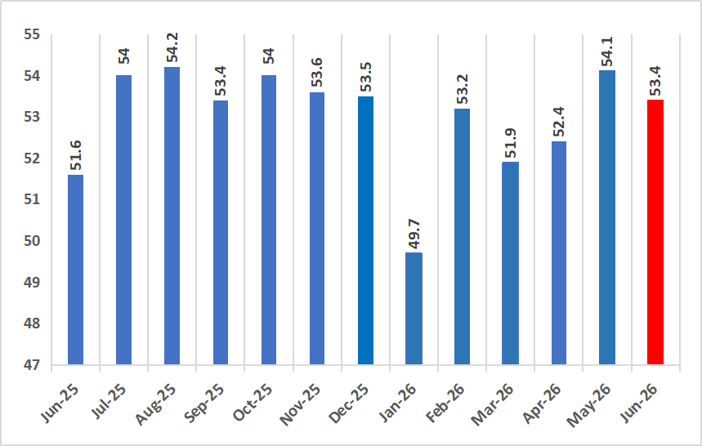
Source: Stanbic-IBC

Nonetheless, the growth outlook remains subject to several downside risks. Inflationary pressures, although easing gradually, continue to weigh on household purchasing power and business operating costs. In addition, persistent insecurity in key food-producing areas, exchange rate pressures, adverse weather conditions, rising fertiliser costs and continued volatility in the global economic environment could constrain agricultural production, investment activity, capital inflows and overall growth performance.

Overall, the available high frequency indicators point to sustained economic resilience, supported by robust domestic demand, improving private sector confidence and ongoing macroeconomic reforms. Preserving this momentum will require continued commitment to macroeconomic stability, accelerated implementation of structural reforms, improved infrastructure, enhanced access to finance, higher agricultural productivity and sustained investment in human capital to foster broad-based, inclusive and durable economic growth
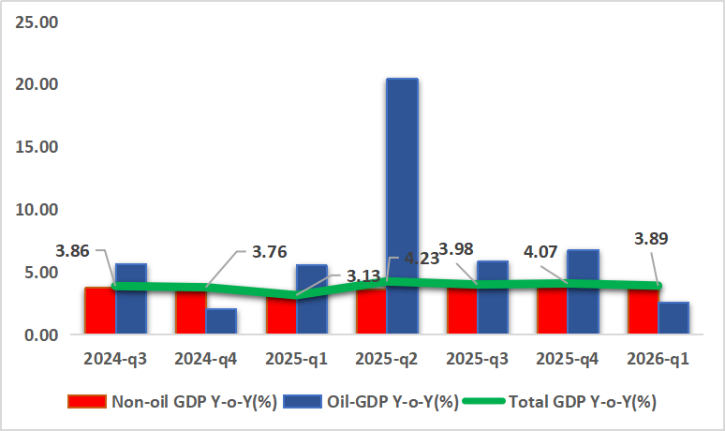
Figure 3: Real GDP Growth Rate in Nigeria (Q32024 – Q12026) in percent

Source: National Bureau of Statistics (NBS)

Output Growth Outlook
Nigeria’s economic performance remained broadly resilient through the first half of 2026, supported by ongoing macroeconomic reforms, improvements in foreign exchange market conditions, and continued expansion of the services sector. The economy has also benefited from gradually improving investor confidence, enhanced FX liquidity, and a modest recovery in crude oil production. While growth remains below its long-term potential, available indicators suggest that overall economic activity has continued to expand at a moderate but steady pace, reflecting improved macroeconomic stability relative to the challenges experienced in recent years.
Looking ahead to the second half of 2026, economic growth is expected to strengthen gradually, albeit unevenly across sectors. Activity in the third quarter is likely to benefit from improved access to foreign exchange, increased business confidence, and seasonal gains in agricultural production associated with the harvest cycle. The services sector—including telecommunications, financial services, transportation, and trade—is expected to remain the principal driver of growth, supported by ongoing digitalization, financial sector expansion, and improving business conditions.
Growth momentum is projected to strengthen further during the fourth quarter of 2026. Increased public spending associated with budget implementation, stronger year-end commercial activity, and the gradual pass-through of recent macroeconomic reforms are expected to provide additional support to aggregate demand. Furthermore, greater stability in the foreign exchange market and a moderation in inflationary pressures could improve household purchasing power and business planning, thereby supporting broader economic activity. Nevertheless, the pace of expansion is expected to remain moderate, constrained by still-elevated borrowing costs, weak real incomes, and persistent structural bottlenecks.
Developments in the oil sector present both opportunities and risks for the outlook. The easing of tensions in the Middle East and the subsequent moderation in crude oil prices toward the end of June have reduced some global inflationary pressures. However, oil markets remain vulnerable to renewed geopolitical disruptions and supply shocks. For Nigeria, oil price volatility presents a mixed picture: higher prices could support fiscal revenues, export earnings, and external reserves, while sharp fluctuations may complicate budget execution, exchange-rate management, and investment planning. As a result, overall growth performance will remain sensitive to developments in global energy markets and external financial conditions.
External risks also remain significant. Tighter global financial conditions, persistent geopolitical uncertainties, and slower growth among major trading partners could adversely affect capital flows, investor sentiment, and external financing conditions. Exchange-rate pressures and imported inflation risks have declined compared with earlier in the year but remain important considerations for policymakers. Consequently, private-sector investment decisions are likely to remain closely tied to perceptions of macroeconomic stability and policy consistency.
Over the medium term, Nigeria’s growth prospects are expected to improve gradually as the benefits of ongoing reforms become more firmly embedded. Continued improvements in policy credibility, deeper foreign exchange market reforms, stronger domestic revenue mobilization, and enhanced investor confidence are expected to support increased public and private investment. In addition, expanding digital economic activity, financial inclusion initiatives, and ongoing efforts to strengthen non-oil exports could contribute to a more diversified and resilient growth model.
Notwithstanding these positive prospects, the sustainability of stronger growth will depend critically on addressing long-standing structural constraints. Key challenges include inadequate infrastructure, unreliable power supply, high logistics and transportation costs, insecurity in some parts of the country, and limited access to affordable financing for businesses. Progress in these areas will be essential to unlocking productivity gains, improving competitiveness, and attracting larger volumes of domestic and foreign investment.
Overall, Nigeria’s growth outlook for the remainder of 2026 remains cautiously optimistic. Economic activity is expected to strengthen gradually, supported by improving macroeconomic fundamentals and reform momentum. However, the expansion is likely to remain moderate rather than rapid, reflecting both external uncertainties and persistent domestic structural challenges. Sustained policy implementation, macroeconomic stability, and continued progress on structural reforms will be crucial to achieving stronger and more inclusive growth over the medium term.
Figure 4: Economic Policy Uncertainty (EPU) index for Nigeria Jan. 2025 – May 2026
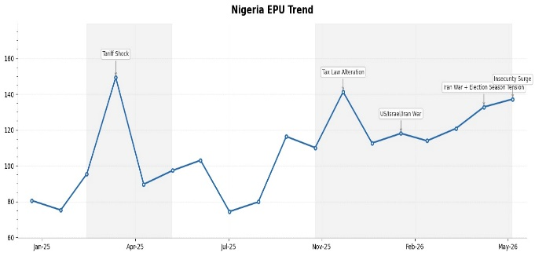
Source: CAPE Economic Research and Consulting, 2026
Our Nigerian Economic Policy Uncertainty (EPU) Index points to a renewed build-up in uncertainty, with the index rising from 132 in April 2026 to 137 in May 2026, extending the upward trend that began after February. This suggests that policy uncertainty has remained elevated despite the implementation of major fiscal reforms earlier in the year.
The recent increase appears to be driven by a combination of heightened domestic security concerns and growing political uncertainty ahead of the 2027 election cycle, alongside persistent geopolitical risks. While uncertainty associated with the implementation of the new tax laws moderated after the initial spike in December 2025, new concerns have emerged, particularly around worsening insecurity in parts of the country and increased political activity as the election season gathers momentum. These developments have sustained elevated media attention on policy and governance risks.
Furthermore, external developments continue to exert pressure on the domestic policy environment. Although the direct uncertainty arising from the Middle East conflict has eased somewhat from its January peak, the lingering effects of global energy market volatility and supply chain disruptions continue to influence Nigeria's macroeconomic outlook, especially through inflation expectations and fiscal management challenges.
Overall, the latest reading suggests that Nigeria's policy environment remains characterised by persistent uncertainty rather than transitory shocks. The gradual increase in the EPU index over the last three months indicates that concerns have shifted from isolated policy events to broader structural issues, including security challenges, the political transition toward the 2027 elections, and the implementation of ongoing economic reforms. If these uncertainties persist, they could weigh on private investment, business confidence, and medium-term economic planning.

Price Update
Nigeria's headline inflation rate increased marginally to 15.93 per cent year-on-year in May 2026 from 15.69 per cent in April 2026, reflecting sustained price pressures across the economy. The Consumer Price Index (CPI) rose to 140.7 points from 138.3 points in the preceding month, indicating a 2.4-point increase in the general price level. However, on a month-on-month basis, headline inflation moderated further to 1.75 per cent, compared with 2.13 per cent recorded in April, suggesting that although prices continued to rise, the pace of increase slowed during the month. Compared with 26.06 per cent recorded in May 2025, headline inflation remained substantially lower, reflecting the combined effects of the rebased inflation methodology, relative exchange rate stability and favourable base effects.

Figure 5: Year-on-Year Headline, Food and Core Inflation in Nigeria (Apr. 2025 – May. 2026)
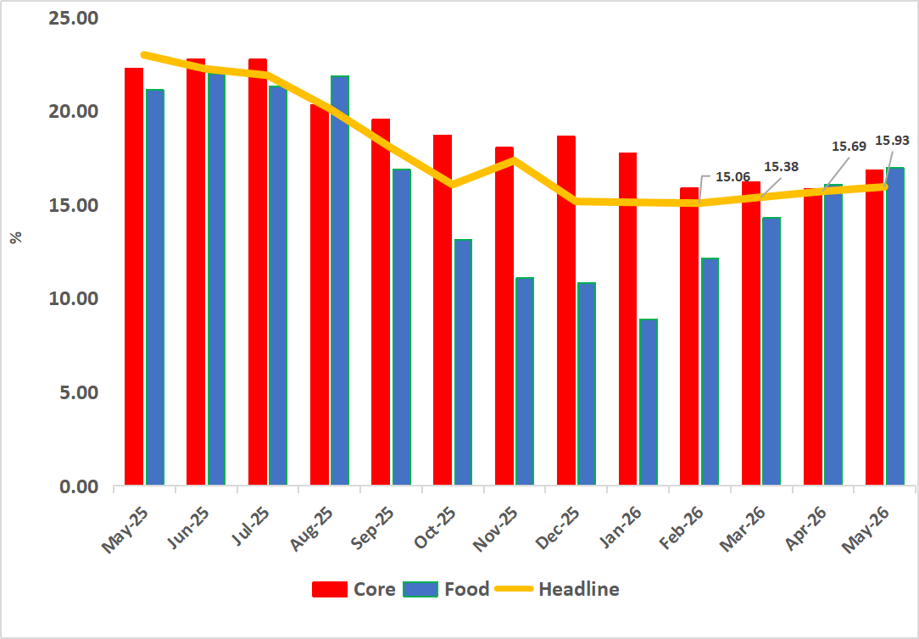
Source: National Bureau of Statistics (NBS)

Food inflation moderated further during the review period. Year-on-year food inflation eased to 16.96 per cent in May 2026 from 24.55 per cent in the corresponding period of 2025, while month-on-month food inflation declined to 2.98 per cent from 3.63 per cent in April. The moderation reflected improved supply conditions for some agricultural commodities, notwithstanding continued increases in the prices of key food items, including fresh onions, maize, egusi, water yam, cassava flour, crayfish, fresh pepper, tomatoes, wheat grain, yam tubers, sweet potatoes, ginger, plantain and cowpea. Consistent with this trend, the twelve-month average food inflation rate declined significantly to 16.99 per cent, compared with 33.21 per cent recorded a year earlier, indicating a broad easing in food price pressures.
Core inflation, which excludes volatile agricultural produce and energy prices, remained relatively elevated, highlighting persistent underlying inflationary pressures. On a year-on-year basis, core inflation stood at 16.82 per cent in May 2026, significantly lower than the 24.92 per cent recorded in May 2025. However, on a month-on-month basis, core inflation accelerated to 1.94 per cent from 1.03 per cent in April, suggesting renewed price pressures across non-food components, particularly services and consumer goods. Nevertheless, the twelve-month average core inflation rate moderated to 19.59 per cent, compared with 27.05 per cent in the corresponding period of 2025, indicating that medium-term underlying inflationary pressures continued to ease despite the recent monthly uptick.
Overall, the May 2026 (month-on-month) inflation outturn suggests that Nigeria's disinflation process remains broadly on track, notwithstanding the marginal increase in annual headline inflation. The continued moderation in month-on-month headline and food inflation, together with the sustained decline in twelve-month average inflation measures, points to improving price stability. However, the rebound in monthly core inflation indicates that underlying inflationary pressures remain elevated, underscoring the need for continued monetary policy vigilance alongside complementary fiscal and structural measures aimed at strengthening domestic supply, improving food security and sustaining exchange rate stability.

Fiscal Operations Update
Nigeria’s Fiscal operations remained robust during the review period, supported by resilient revenue performance despite mixed outturns across the major revenue sources. Higher collections from petroleum-related taxes and corporate income tax offset weaker receipts from consumption-based taxes and customs duties, resulting in a further improvement in distributable federation revenue. The sustained growth in revenue reflects the continued benefits of ongoing fiscal reforms, improved revenue administration and favourable performance in the hydrocarbon sector.
The Federation Account Allocation Committee (FAAC) distributed ₦2.300 trillion to the three tiers of government from May 2026 revenue, representing an increase of ₦43.0 billion, or 1.9 per cent, above the ₦2.257 trillion shared in the preceding month. The increase extended the upward trajectory in federation allocations, thereby providing additional fiscal resources to support government expenditure at the federal, state and local government levels.
Of the total distributable revenue, the Federal Government received ₦818.680 billion, representing 35.6 per cent of the total allocation, while the 36 state governments received ₦759.141 billion or 33.0 per cent. The 774 Local Government Councils received ₦534.277 billion, accounting for 23.2 per cent, while the oil-producing states received ₦188.132 billion as 13 per cent derivation revenue, representing 8.2 per cent of the distributable pool.
Figure 6: Total Distributable Revenue (Jan – May. 2026)
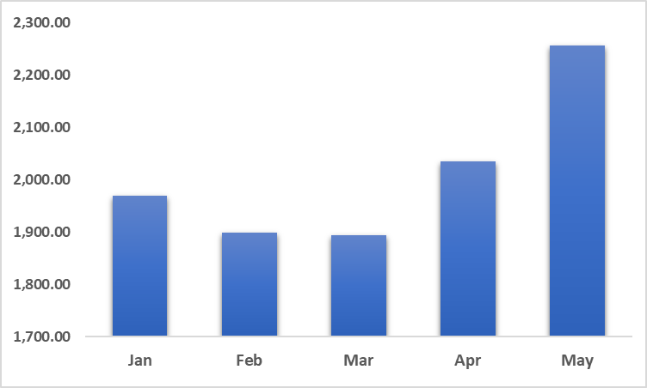
Source: FAAC
The improved revenue performance was largely driven by stronger statutory revenue arising from increased collections of Companies Income Tax (CIT), Petroleum Profits Tax (PPT), Hydrocarbon Tax and oil and gas royalties, which more than compensated for the decline in Value Added Tax (VAT), import duties and excise duties during the period. The increase in petroleum-related revenues underscores the continued importance of the hydrocarbon sector in supporting government finances, while the growth in corporate tax collections suggests improving profitability and compliance within the formal sector.
Looking ahead, the fiscal outlook remains cautiously positive, supported by ongoing tax administration reforms, improved non-oil revenue mobilisation efforts and relatively resilient hydrocarbon receipts. Nevertheless, downside risks remain, including volatility in international crude oil prices, lower consumption-related tax collections, global economic uncertainty and the continued need to strengthen domestic revenue mobilisation to reduce fiscal vulnerabilities. Sustaining fiscal resilience will require continued improvements in revenue administration, enhanced tax compliance, prudent expenditure management and accelerated implementation of fiscal and structural reforms to broaden the revenue base and strengthen public finances.

Conclusion
The global economy remained resilient during the first half of 2026, but the operating environment became increasingly complex and uncertain. While global growth has continued at a moderate pace, the outlook remains constrained by geopolitical tensions, elevated policy uncertainty, tighter financial conditions, and the ongoing reconfiguration of global trade and investment patterns. Although the June ceasefire agreement between the United States and Iran helped reduce immediate risks to global energy markets and improved investor sentiment, downside risks continue to stem from potential geopolitical flare-ups, commodity price volatility, and persistent inflationary pressures.
Against this backdrop, Nigeria has made notable progress in restoring macroeconomic stability. The combination of sustained monetary policy tightening, foreign exchange market reforms, improved fiscal management, and strengthening investor confidence has contributed to greater stability in financial markets and improved external sector conditions. Enhanced FX liquidity and gradual improvements in policy credibility have helped support economic activity despite a challenging global environment. However, the persistence of elevated economic policy uncertainty indicates that the economy remains vulnerable to external shocks, particularly those arising from fluctuations in global oil prices, changing investor risk appetite, and evolving international financial conditions.
Looking ahead, Nigeria’s economic outlook remains cautiously optimistic. Growth is expected to strengthen gradually during the second half of 2026, supported by improvements in foreign exchange market conditions, continued services-sector expansion, recovering investor confidence, and increased economic activity associated with year-end spending. Moderating inflationary pressures and a more stable macroeconomic environment are also expected to provide support for domestic demand and business activity. Nevertheless, the pace of expansion is likely to remain moderate, reflecting the effects of elevated borrowing costs, weak household purchasing power, and persistent structural constraints.
External developments will continue to play a significant role in shaping economic outcomes. While the recent moderation in crude oil prices has reduced immediate global inflationary pressures, continued volatility in commodity markets and uncertainty surrounding global growth prospects present both opportunities and risks for Nigeria. Higher oil prices could strengthen fiscal revenues and external balances, whereas renewed market volatility could adversely affect exchange rates, capital flows, and inflation dynamics. Consequently, maintaining macroeconomic stability will require continued vigilance and effective policy coordination.
Over the medium term, stronger and more inclusive growth will depend on the successful implementation of ongoing structural reforms. Addressing critical infrastructure gaps, improving energy reliability, reducing logistics and transportation costs, strengthening security, and enhancing the business environment remain essential for raising productivity and attracting investment. Continued progress in diversifying the economy, deepening non-oil export capacity, and expanding digital and financial inclusion initiatives will also be critical to building economic resilience.
Accordingly, policy priorities should focus on preserving gains achieved through recent reforms while accelerating measures that support long-term competitiveness. Sustained monetary and exchange-rate discipline, prudent fiscal management, rebuilding fiscal buffers, and targeted investments in infrastructure and human capital will be essential to strengthening growth prospects and reducing vulnerabilities to future shocks.
Overall, Nigeria enters the second half of 2026 from a stronger macroeconomic position than in previous years, supported by improving policy credibility and a more stable economic environment. However, the economy continues to operate within a global landscape characterized by elevated uncertainty and evolving risks. The ability of policymakers to maintain reform momentum, reinforce macroeconomic stability, and translate stabilization gains into broad-based and sustainable economic growth will be crucial in determining the country's medium-term development trajectory.

Country in Focus –Republic of Congo DRC
Figure 7: Economic Parameters for Republic of Congo DRC
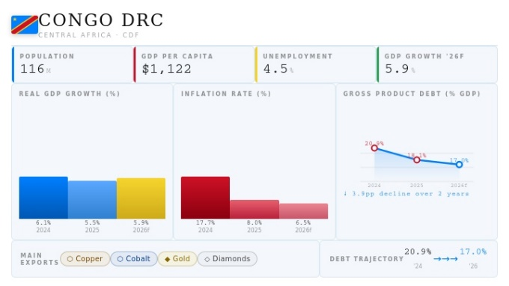
Source: CAPE Economic Research and Consulting, 2026

